# Create a New Service Target for a Platinum Application

Service Level Management

**Purpose**

To measure and report on SLAs for Platinum applications, a single Service Target is created. The Service Target will be related to an Agreement. It will also be defined in the Master Record for the individual service in order to be reported on.

**Related Policy**

* [IT Service Management Policy](https://sharepoint.jackson.com/sites/itsmsd/servicelevelmanagement/Shared%20Documents/Pre%20December%202019/SLM%20Documents/Policy%2C%20Process%2C%20Procedures/SLM_Service%20Level%20Management%20Process.doc?d=wa1eaba53e1dc4b30abda2a0886981cc9)

**Audience**

The following groups are responsible for adhering to this document:

* Service Level Management

**Procedure**

|  |  |
| --- | --- |
| Step | Action |
| 1 | Once a Platinum application is identified and the Service Target metrics are defined, the Service Target can be built.   1. Service Target data can be reviewed here:   [Appendix D7 Application Maintenance](https://sharepoint.jackson.com/sites/itsmsd/servicelevelmanagement/Shared%20Documents/Appendixes/Jackson%20-%20TML%20-%20Appendix%20D7%20-%20Service%20Levels%20%20Tower%207%20Application%20Maintenance%20(Jackson%20TM%20Final%20)%20(MLB%20Edits).xlsx?d=w1d807f2962e54acb96824568f5cac77d) and  [Metric Database CPI Data](https://sharepoint.jackson.com/sites/itsmsd/servicelevelmanagement/_layouts/15/WopiFrame.aspx?sourcedoc=%7b286CA760-ACDC-4B1C-B755-9D4D1E8A3AED%7d&file=Metric%20Database%20CPI%20data.xlsx&action=default) |
| 2 | To access Service Level Management in Remedy to verify if a viable Service Target already exists, follow the instructions below:   1. In the Remedy system, select the Applications tab on the side. 2. Select “Service Level Management” 3. Select “Service Level Management Console”      1. On the “SLM Console” tab, click the “Folders” drop down-arrow. 2. Click “Standard Services” drop down-arrow. 3. Click “Monitored”      1. Click on the “Service Targets” tab   This will show existing Service Targets that have been created.  See **Appendix A** for the standard naming convention.     1. If you need to review an existing Service Target, highlight the specific Service Target name in the list. 2. Click the “View” button.      1. If a viable Service Target already exists that matches the criteria found in the Metric Data Definition for the specified service, you are done with this procedure. 2. If the desired Service Target does not exist, continue to Step 3. |
| 3 | **To Create a Service Target**   1. Click the “Create” button.     “Step 1 of 4” will appear on the screen after clicking the “Create” button. There are four steps to complete.   * + Step 1 – General information   + Step 2 – Goals, costs, and business schedules   + Step 3 – Measurement criteria   + Step 4 – Milestones and actions  1. Continue to Step 4 to set up “Step 1 of 4”. |
| 4 | **SERVICE TARGET (STEP 1 of 4)**   1. Select the “Advanced” option.   This will auto-populate the “Agreement Type”, “Status”, and “Effective From” fields.   1. Update the “Effective From” field.  * Date – The first of the month in which you want to start using the Service   Target.   * Time – 12:00:00 AM   ***Note:*** *This sets the “SLA Time Scheduled” field on the Event Schedule form.*  For more information see:  [Event Schedule Form Documentation](https://confluence.jacksonnational.com/display/CPENABLE/02+-+Event+Schedule+Form+Documentation?preview=/575465558/575465562/Event%20Schedule%20Form%20Documentation.docx)     1. Enter information in the following fields:  * **Title:** Name the Service Target.   See ***Appendix A*** for the standard naming convention.   * **Description:** Enter the application name. * **Applies To**: Select “CI Unavailability” from drop down list. * **Goal Type**: Select “CI Outage” from drop down list. * **Related CI’s**: To set the Configuration Item, follow d) through l) below.      1. Click the “Define” button to relate an existing application.      1. Click the “Relate” button      1. Perform a search in the “CI Name” field.      1. Click the “Search” button.      1. Select the correct application name that ends with “Tech Service”.      1. At the bottom of the screen, enter the same date that was used in the “Effective From” field (Step 4 b)) in the “Start Tracking From” field. The start date and time should always be the first of the month and be 12:00:00 AM (this allows a new   measurement record to be created at the start of each new month).  ***Note:*** *This sets the “OverallStartTime” field on the Measurement Record.*  For more information see:  [Measurement Record Documentation](https://confluence.jacksonnational.com/display/CPENABLE/01+-+SLM+Measurement+Record+Documentation?preview=/575465542/575465548/Measurement%20Record%20Documentation.docx)   1. Select the Business Entity from the drop-down menu.      1. Click the “Relate” button      1. Ensure that the correct application name, Business Entity, and Start Time appear.   ***Note:*** *On the first of each month at 12:00:00 AM when a new Measurement Record is created, the “Start Time” will update to match the current month’s “OverallStartTime” field of the Measurement Record.*     1. Click the “Close” button 2. Click the “Next” button. |
| 5 | **Goals & Costs (STEP 2 of 4)**  At this time no information needs to be added on this screen.   1. Click the “Next” button. |
| 6 | **Measurement Criteria (STEP 3 of 4)**   1. Type the following information in the “Outage Condition” field:   'Unavailability Type' = "Unscheduled Full" OR 'Unavailability Type' = "Unscheduled Partial"  ***Note:*** *This information is used to invoke a CI Unavailability record when an Incident ticket is created for a service outage.*     1. The “Description” is left blank. 2. Lifecycle Interval is “1” Month      1. Click the “Next” button. |
| 7 | **Milestones and Actions (STEP 4 of 4)**  Milestones can use Milestone templates or be customized. To use Milestone templates, follow a) through f) below or to create a customized Milestone, follow g) through l) below:  ***Note:*** *Milestones are not currently being used at this time due to system glitches in which numerous emails are generated and / or the emails are not sent when they should be. This step should be left intact for when these issues are resolved.*   1. Click the “Add” button under the “Milestones” box.      1. Click the down-arrow at the “Select” field. 2. Select “Template”.      1. A list of Milestone templates will appear. Find the Milestone you are looking for and click it.     For more information see:  [Create a Milestone Template Procedure](https://confluence.jacksonnational.com/display/CPENABLE/Create+a+Milestone+Template?preview=/610910996/610912781/Create%20a%20Milestone%20Template%20Procedure.docx)   1. Click the “OK” button. 2. Repeat a) through e) until all requested Milestones have been added.      1. To create a customized Milestone, click the “Add” button.      1. Click the down-arrow at the “Select” field. 2. Select “Custom”. 3. Select “New Milestone” 4. Click the “OK” button.      1. See Step 3 d) through e) of the [Create a Milestone Template Procedure](https://confluence.jacksonnational.com/display/CPENABLE/Create+a+Milestone+Template?preview=/610910996/610912781/Create%20a%20Milestone%20Template%20Procedure.docx) to complete the customized milestone, substituting the specific parameters for the milestone you are creating for the specific application.     On the same screen, corresponding Actions will need to be linked to each Milestone.  To use Milestone Action templates follow m) through t) below or to create a customized Milestone Action, follow u) through z) below:  ***Note:*** *Actions are not currently being used at this time due to system glitches in which numerous emails are generated and / or the emails are not sent when they should be. This step should be left intact for when these issues are resolved.*   1. In the Milestone box click on the appropriate Milestone in which an Action is to be linked. 2. Click the “Add” button under the “Actions” box.      1. Select the down-arrow. 2. Select “Template” 3. A list of Action templates will appear. Find the Action you are looking for and click it.     For more information see:  [Create a Milestone Action Template Procedure](https://confluence.jacksonnational.com/display/CPENABLE/Create+a+Milestone+Action+Template?preview=/610911005/610912797/Create%20a%20Milestone%20Action%20Template%20Procedure.docx)   1. Ensure that the percentage in the template matches the Milestone to which it is   being linked to. (example; a 50% Milestone of 98% Service Target needs to have  a 50% of 98% Milestone Action).   1. Repeat m) through r) until the corresponding Milestone Actions have been linked to each Milestone. 2. Verify that each Milestone percentage matches the Milestone Action percentage by clicking on the Milestones one at a time.      1. To create a customized Milestone Action, click the “Add” button.      1. Click the down-arrow at the “Select” field. 2. Select “Custom”. 3. Select “New Alert or Email Action”.   ***Note:*** *At this time “New Alert or Email” are the only actions being performed.*   1. Click the “OK” button.      1. See Step 3 e) through f) of the [Create Milestone Action Template Procedure](https://confluence.jacksonnational.com/display/CPENABLE/Create+a+Milestone+Action+Template?preview=/610911005/610912797/Create%20a%20Milestone%20Action%20Template%20Procedure.docx) to complete the customized action milestone, substituting the specific parameters for the Milestone Action you are creating for the specific application. |
| 8 | Once all four Steps have been completed it is time to build the Service Target.   1. Click the “Finish” button.      1. Click the “Yes” button.      1. This will return you to the main Service Level Management screen.   Follow Steps 2 e) through 2 i) to locate the required Service Target that has just been created.   1. “Built Successfully” or “Build in Progress” are expected. If the status is “Build in Progress”, click the “Refresh” button until the status updates to “Built Successfully”. 2. Once the status of “Built Successfully” appears, verify that a Measurement Record has been created and that the “OverallStartTime” field matches the “Start Time” that was used when relating a CI to the Service Target. It should be 12:00:00 AM of the current month.   For more information see:  [Measurement Record Documentation](https://confluence.jacksonnational.com/display/CPENABLE/01+-+SLM+Measurement+Record+Documentation?preview=/575465542/575465548/Measurement%20Record%20Documentation.docx)   1. Verify the “SLA Time Scheduled” field on the Event Scheduled form for the Service Target that was just created. It should be 12:00:00 AM on the first date of the following month. This states when a new Measurement Record will be created.   For more information see:  [Event Schedule Form Documentation](https://confluence.jacksonnational.com/display/CPENABLE/02+-+Event+Schedule+Form+Documentation?preview=/575465558/575465562/Event%20Schedule%20Form%20Documentation.docx)   1. After the Service Target has been created, the Measurement Record, and Event Schedule Form have been verified, an Agreement and a Master Record will need to be created.   For more information see:  [Create an Agreement Procedure](https://confluence.jacksonnational.com/display/CPENABLE/Create+an+Agreement?preview=/610910990/610910993/Create%20an%20Agreement%20Procedure.docx)  [Create a Master Record Procedure](https://confluence.jacksonnational.com/display/CPENABLE/Create+a+Master+Record?preview=/610910994/610912849/Create%20a%20Master%20Record%20Procedure.docx)   1. Locate the Service Target that has just been created.      1. If “Could Not Be Built” or “Needs to Be Built” appears, highlight the Service Target and click the “Build” button.      1. Click the “Yes” button.      1. Click the “Refresh” button until the status changes from “Build in Progress” to “Built Successfully”. 2. If the status returns to “Could Not Be Built”, see ***Appendix B.*** |

**Appendix A – Service Target Standard Naming Convention**

The Service Target name should follow this format:

***SVT-CIU-AAA-99***

***AAA*** – Service Name

Use the service name that is found in the [Appendix D7 Application Maintenance](https://sharepoint.jackson.com/sites/itsmsd/servicelevelmanagement/Shared%20Documents/Appendixes/Jackson%20-%20TML%20-%20Appendix%20D7%20-%20Service%20Levels%20%20Tower%207%20Application%20Maintenance%20(Jackson%20TM%20Final%20)%20(MLB%20Edits).xlsx?d=w1d807f2962e54acb96824568f5cac77d) or

Metric Database CPI Data. These will match the Service names that appear in Remedy.

***Note:*** *If a service name contains any text in parenthesis, do not include the parenthesis in the Service Target name. Use a space or a hyphen between the service name and the acronym.*

**

***Example:*** *Cash Disbursement System (CDS) should be:*

*SVT-CIU-Cash Disbursement System-CDS-99*

**99** = Compliance target percentage.

***Note:*** *There is a set Compliance Target for each service and a Minimum Compliance Target as well. Due to a current restriction on the Master Record in which only two characters can be displayed as the Compliance Target on the SLA Report, 99 is the standard Compliance Target that is used.*

***Example***: SVT-CIU-Cash Disbursement System-CDS-99

***Note:*** *The compliance target percentage number is needed in the title as it is used to auto-populate the “Compliance Target” field when the Master Record is created.*

For more information see:

[Create a Master Record Procedure](https://confluence.jacksonnational.com/display/CPENABLE/Create+a+Master+Record?preview=/610910994/610912849/Create%20a%20Master%20Record%20Procedure.docx)

***Note:*** *Legacy applications that were identified as Platinum in 2019 contain extra characters that represent the acronym for the Business Unit. The acronym is no longer required in the Service Target title.*

**Appendix B – Service Target “Could Not Be Built” status.**

In the event that a Service Target has a status of “Could Not Be Built”, verify the following:

* The Service Target name does not include parenthesis in the title.
* Compare the Data Sources between Production and Development to ensure there are no differences.

1. In both Production and Development Remedy, select the Applications tab on the side.
2. Select “Administrator Console”.
3. Select “Application Administration Console”
4. Click the “Custom Configuration” tab
5. Click “Service Level Management”

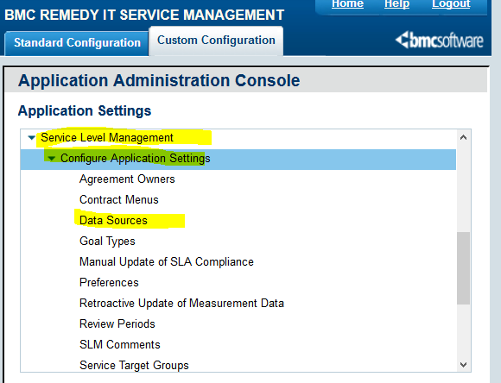

1. Click “Data Sources”. A list will appear.

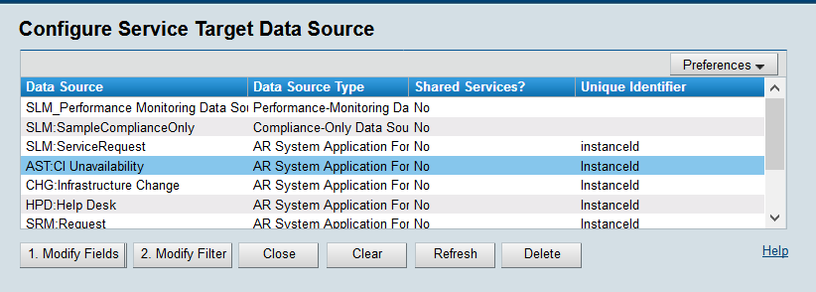

1. Click on “AST: CI Unavailability”. Information will appear at the bottom of the screen. Ensure that the following fields match between Production and Development.

* Data Source / App Form
* Data Source Display As
* Field as Unique Identifier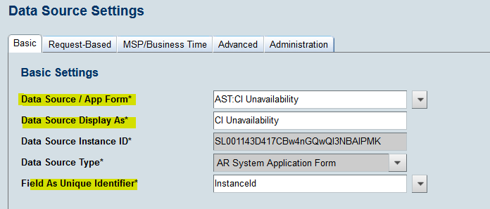
* If these do not match, create an Incident ticket for ITSM Suite Administration to

investigate which one is correct. Ensure to enter the Service Target name and all

relevant details.

* If these do match up, then delete the Service Target that has been created and rebuild

It.

***Note***: *Once the Data Sources are set, they should not have to be updated again*.

**Modification**

The following associates can make modifications to this document:

* Manager, Service Level Management
* Director, IT Service Management
* Vice President, Service Delivery
* Chief Technology Officer, PGDS

|  |  |
| --- | --- |
| Service Level Management Process | |
| Responsible Party: Sharla Piepkow, Manager, Service Level Management Approving Authority: Rob Kolm Director, IT Service Management | Date Created: 04/28/2020 Last Modified:  Last Reviewed: |